PROJECT REPORT

DESIGN PROPOSAL DRAFT-I

**DEVELOPMENT OF LOW COST VENTILATION SYSTEM**

&

**SCOPE OF IMPLEMENTATION**

REPORT BY

AKSHAY SRIVASTAVA

**NOMENCLATURE**

|  |  |
| --- | --- |
| **Pmax** | Maximum lung/alveolar Pressure |
| **PEEP** | Positive end expiratory pressure |
| **FIO2** | Fraction of Inhaled oxygen |
| **RRmech** | Rate of Respiration (mechanical) |
| **RRoptimal/*f***  **VT**  **VT,optimal** | Optimized Rate of Respiration  Tidal Volume  Optimal Tidal Volume |
| **Pinsp** | Inhalation Pressure |
| **WOB** | Work on Breath |
| **Vd** | Dead Space Volume |
| **RC** | Time Constant of Respiration |
| **I/E** | Ratio of Inhalation/Expiration Time |
| **TE** | Expiratory Time |
| **IBW** | Ideal Body Weight |
| **%MV**  **C’**, **C**  **Rrs**  **Ti**  **VCAC**  **PCAC**  **PSV**  **CPAP**  **SIMV (VCV)**  **SIMV (PCV)**  **MMV**  **ASV**  **P**  **PPeak/PIP**  **Ṽ**  **FCF** | % Minute Volume/Ventilation  Respiratory Compliance  Airway Resistance  Time Duration  Volume Control w/ Assist Control  Pressure Control w/ Assist Control  Pressure Support Ventilation  Continuous (+VE) Airway Pressure  Synchronised intermittent Mandatory Ventilation w/ volume control  Synchronised intermittent Mandatory Ventilation w/ Pressure control  Mandatory Minute Ventilation  Adaptive Support Ventilation  Pressure in Lung  Peak Inhalation Pressure  Volumetric Flowrate  Flow Cycle Off |

**REPORT OUTLINE**

**EXECUTIVE SUMMARY** 3

**INTRODUCTION** 4

**MODES OF OPERATION** 8

**DESIGN DRAFT OF THE LOW COST VENTILATOR** 15

# **EXECUTIVE SUMMARY**

The goal of this project is to develop a low cost ventilator which can be remotely assembled (partially if not completely) via the modes of additive manufacturing for emergency situation. Though the cost and design shall be reduced to a bare minimum for easy of manufacturing, the functionality shall be maintained to the state of the art standards in order to allow for ease of implementation and handling for the clinician.

# **INTRODUCTION**

A ventilator is a device that delivers oxygen into the lungs (called oxygenation), remove carbon dioxide from the body and in doing so, helps the patient breathe easier, completely take over the breathing process for people who cannot do so spontaneously or accelerate the healing process of the body by eliminating the expenditure of extra energy while breathing (WOB). A ventilator uses pressure to pump artificial mixture of clinical air and oxygen into the lungs. This pressure is known as positive pressure. In similar manner the exhalation process may be spontaneous or assisted. The amount of fractional oxygen in the air mixture that the patient receives can be controlled through the ventilator system (this is known as FIO2). A ventilator blows air into the airway through a breathing tube which is connected to the ventilator via flexi-tubing knowing as patient circuit. One end of the tube is inserted into patient’s windpipe and the other end is attached to the ventilator via the patient circuit. The breathing tube serves as an airway by letting air and oxygen from the ventilator flows into the lungs. Depending on the patient’s medical condition, a breathing mask may also be used to replace the tubing assembly. Mechanical ventilation is utilized in intensive care and long-term care settings to assist patients who require additional respiratory support. It is indicated for acute or chronic respiratory failure, which is defined as insufficient oxygenation, insufficient alveolar ventilation, or both. Benefits of mechanical ventilation are improved gas exchange and decreased work of breathing (WOB). In order to ensure ease of implementation and handling by a clinician, it is important to understand the parameters that shall be implemented in the device.

* Fraction of inspired oxygen(FIO2): Concentration of oxygen in the inspired air. Typically, the lowest FIO2 that achieves the targeted oxygenation is utilized in order to avoid oxygen toxicity.
* Frequency (f) or Respiratory Rate (RR): The number of ventilator breaths/min. RRactual includes the spontaneous breaths taken by the patient. Hypoventilation may cause respiratory acidosis while hyperventilation may cause respiratory alkalosis (ideal pH ~7.5).
* Trigger: Initiation variable. Breaths can be triggered by (i). Timer (ventilator-initiated breaths) occur at the set rate of respiration or frequency (f). (b). Patient effort (patient initiated breaths) occur when the patient causes sufficient change in either the pressure or flow in the patient circuit.
* Target: A set-point; Flow of air into the lung can target a predetermined flow rate (i.e. peak inspiratory flowrate) or pressure limit.
* Termination: Signal for a ventilator to end inspiration which may be related to volume (i.e. Tidal volume), time (i.e. predetermined duration of inspiration), or flow (decrease in inspiratory flow to a percentage peak value).
* Tidal Volume (Vt): Volume of gas exchanged with each breath. A lower Vt is an indicative of a non-compliant lung where as higher Vt may cause tachycardia, decreased blood pressure and barotrauma.
* Minute Ventilation: Volume of gas exchanged per minute = RR*Vt
* Inspiratory/Expiratory (I:E) ratio: Indicative of the fraction of the breathing cycle dedicated to the inspiration process and to the expiration process. Allows for determination of an equilibrium time in the breathing cycle.
* Positive End Expiratory Pressure (PEEP): Pressure remaining in the lung at end expiration for recruitment of alveoli for improved oxygenation in ARSD patients (common with sar-cov-2 cases inflicted with covid-19 disease). High levels may cause barotrauma, increased intracranial pressure and decreased cardiac output.
* Pressure Support: Provides additional pressure during inspiration to ensure a large Vt with minimal patient effort. Used to help overcome the work of breathing through ventilator tubing.
* Peak Inspiratory Pressure (PIP): Highest proximal airway pressure reached during inspiration. Lower PIP may result in hypoventilation while high PIP may cause lung damage.
* Peak flow rate: Maximum flow delivered by the ventilator during inspiration.

In order to develop a functioning ventilation systems while maintaining the design and cost constraints, it is of utmost importance that the system be limited to basic and essential features. A basic ventilation system has the following salient features:

|  |  |
| --- | --- |
| FEATURE | SUB-SYSTEM |
| Sources of power: | •Gas supply  •Power supply  •Pressure generator |
| Control of gas delivery: | •Gas blender  •Gas accumulator  •Inspiratory flow regulator  •Humidification equipment  •Patient circuit  •Expiratory pressure regulator (i.e PEEP valve) |
| Monitoring | •Sensors   * Gas concentration * Flow * Pressure * Volume |
| Safety features | •Filters   * Gas intake particle filters * Pre-circuit bacteria filters * Moisture traps and heat/moisture exchange systems * Expired gas filter   •Alarms |

**The power source** comprises of the power source for the ventilator as well as the point through which clinical air and oxygen (along with other gases such as nitrogen or anaesthetic gases) may be introduced to the machine. Thus, this category encompasses the gas supply system, the batteries and power source for the mechanical ventilator.

**The controls** are some means of regulating the timing and characteristics of the delivered gas. These components consist of an entire array of parts.

* **A gas blender** is required to control the mixture of air, oxygen and/or anaesthetic gas. Such an arrangement may be omitted while considering the construction of a domiciliary model which requires filtered atmospheric air.
* **A gas accumulator** is a tank in which metered gases may be combined for ventilating the patient on. The composition of these gases is pre-determined.
* **Inspiratory flow regulator** is a flow sensor which determines the amount of the metered gas mixture that will be provided to the patient. Solenoid valve is used
* **Humidification equipment is the equipment that ensures that gas mixture is appropriately humidified and heating. Since the ventilator tubing is directly inserted into the patient, the humidification and heating action of the wind pipe is absent**.
* **The circuit is the flexi-tube connection which connects the endotracheal tube to the ventilator.**
* **Expiratory pressure regulator** (i.e PEEP valve) is a means of maintaining and controlling positive airway pressure in order to recruit the highest amount of lung tissue for mass transfer. Solenoid valves are used.

**The monitors** are means of sensing and presenting the characteristics of gas delivery so that one might be able to assess the ventilator’s performance (and also the patient’s condition).

* **Gas concentration** is usually measured by either voltaic cells or spectrophotometers. For example, the oxygen supply sensor is usually an oxygen cell, which produces an output voltage proportional to the partial pressure of oxygen in the inspiratory gas pipe.
* **Flow** is the measure of volumetric flowrate supplied by the ventilator. Commercially available mechanical ventilators have some method of monitoring flow. These methods include:
  + Hot wire anemometry, where the effect of gas flow on cooling a heated platinum wire is detected as a change in the wires' resistance
  + Variable orifice flowmeters, where a pressure drop across a narrow pipe is used to calculate flow
  + Screen pneumotachography, where a pressure drop across a mesh screen is used to calculate flow
  + Ultrasonic flowmeters, where two transducers are used to analyse changes in ultrasound wave transit time caused by the velocity of the intervening medium.
* **Pressure** in the circuit is maintained by means of aneroid manometers, i.e. pressure sensors that measure air pressure by the action of the air in deforming the elastic lid of an evacuated box. In modern ventilators, these have been superceded by integrated silicon wafer pressure transducers, at a fraction of the cost and with greatly improved accuracy.
* **Volume** is calculated from flow measurements.

**The safety features** are check devices that allow for safety protocols which ensure that the patient does not come to any additional harm from being ventilated. These consist of filters and alarms.

* **Inspiratory filters** of the ventilator promote purity of inspired gas (eg. by removing airborne particles and bacteria from the inspired gas mixture).
* **Expiratory filters** protect the ICU staff. Expired gas is filtered to prevent the ventilator exhausting aerosolised pathogens.
* Expiratory filters are also usually needed to protect the ventilator components from the necessarily hot and humid expired gases, which would degrade the quality of sensor measurements and decrease the lifespan of the device
* **Alarms** are usually integrated into the software as safeguards against unintentional changes to the ventilator settings.

# **MODES OF OPERATION**

State of the art ventilators are well equipped with a multitude of operation modes. The following modes of are mandatory for basic ones, but via data collection, advanced modes may also be incorporated:

* VCV Volume Control (Assisted/Controlled): Volume assist-control ventilation (ACV) is a ventilator mode in which the machine delivers the same tidal volume during every inspiration, whether initiated by the ventilator or by the patient. This occurs regardless of the mechanical load on the respiratory system and no matter how strenuous or feeble the inspiratory muscle effort. The main reasons for using ACV are to unload the inspiratory muscles and to improve gas exchange. ACV permits complete respiratory muscle rest, which is usually the case when patients do not trigger the machine, and a variable degree of respiratory muscle work. ACV commonly achieves an improvement in gas exchange, and only a minority of ventilated patients die because of refractory hypoxemia. In this mode of operation, the clinician sets the following parameters:
  + Tidal Volume.
  + Flow Rate.
  + PEEP.
  + Sensitivity.
  + FIO2.
  + Flow Rise.
  + Apnea Criteria

The graph for Airway Pressure, Volumetric Flowrate, Tidal Volume v/s Time period for VCV is as shown below:

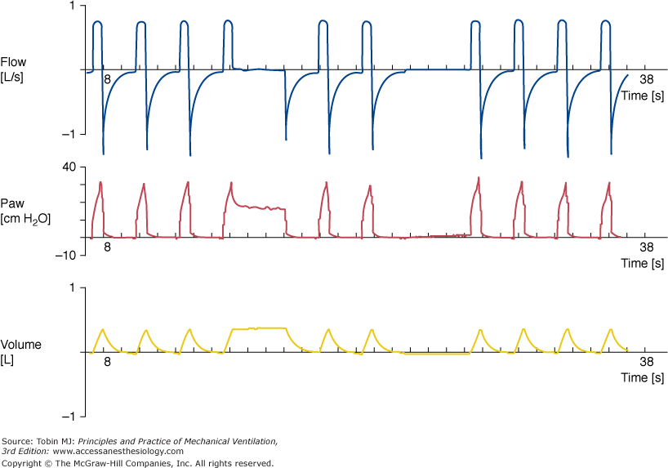

In this case, since a given amount of tidal volume is delivered to the lung, the airway pressure and PIP is a variable since lung compliance and airway resistance remain unaccounted for in this mode. Furthermore, the breath may be patient triggered (by the detection of a negative airway pressure), but the apnea parameter delivers the breath regardless of the patient trigger after a certain time of inactivity to avoid asphyxiation.

* PCV Pressure Control (Assisted/Controlled): Pressure assist-control ventilation (ACV) is a ventilator mode in which the machine delivers the same airway pressure during every inspiration, whether initiated by the ventilator or by the patient. This occurs regardless of the mechanical load on the respiratory system and no matter how strenuous or feeble the inspiratory muscle effort. The main reasons for using ACV are to unload the inspiratory muscles and to improve gas exchange. ACV permits complete respiratory muscle rest, which is usually the case when patients do not trigger the machine, and a variable degree of respiratory muscle work. ACV commonly achieves an improvement in gas exchange, and only a minority of ventilated patients die because of refractory hypoxemia. In this mode of operation, the clinician sets the following parameters:
  + Peak Inspiration Pressure (PIP).
  + Time Duration of Respiration, Ti.
  + PEEP.
  + Sensitivity.
  + FIO2.
  + Pressure Rise.
  + Apnea Criteria

The graph for Airway Pressure, Volumetric Flowrate, Tidal Volume v/s Time period for PCV is as shown below:

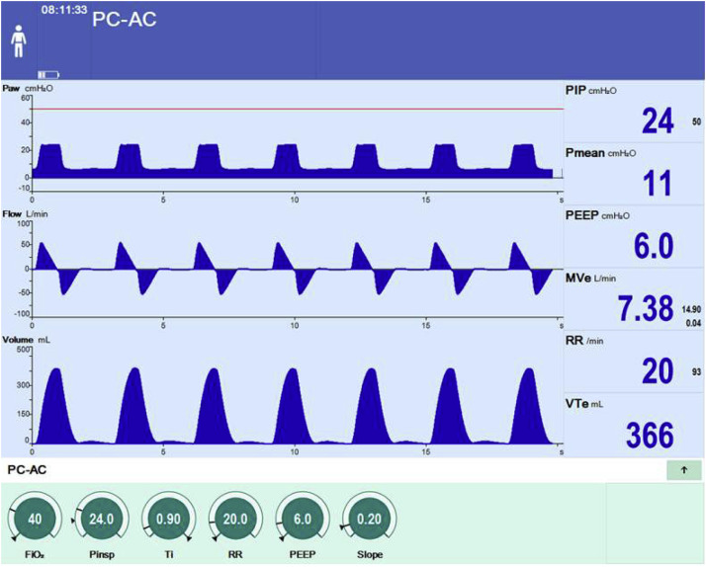

In this case, since a given amount of airway pressure is delivered to the lung, the tidal volume and the flow are variables since lung compliance and airway resistance are accounted for in this mode. Furthermore, the breath may be patient triggered (by the detection of a negative airway pressure), but the apnea parameter delivers the breath regardless of the patient trigger after a certain time of inactivity to avoid asphyxiation. This method is considered to be a lung protective mode of operation.

* PSV Pressure Support: Pressure-support ventilation (PSV) is a mode of partial ventilator support. PSV is a pressure-targeted (or limited) mode in which each breath is patient-triggered and supported. It provides breath-by-breath support by means of a positive-pressure boost synchronized with inspiratory effort: patient initiated and flow terminated. During inspiration, airway pressure is raised to the pre-set pressure-support level. The speed of pressurization is system specific but most recent ventilators offer the possibility of adjusting this pressurization rate. Throughout the inspiratory phase, the ventilator works as a pressurized demand-flow system at a predetermined pressure level. PSV is maintained until the machine determines the end of expiration, supposedly reflecting the end of patient demand. The expiratory trigger mechanism is based on decay of inspiratory flow. When inspiratory flow falls below a threshold value, which should indirectly indicate that the inspiratory muscles have relaxed, the ventilator cycles to the expiratory phase releasing the PSV and opening its expiratory port. A level of positive end-expiratory pressure (PEEP) lower than the inspiratory plateau pressure can then be applied. PSV can thus be defined as a patient-initiated (pressure or flow), pressure-targeted, flow-cycled mode of mechanical ventilation. Upon the detection of a negative pressure in the airway, the system delivers a pressure support to augment a tidal volume. As the pressure provided by the system and the airway pressure begin to equalize, the nature of flow begins to decay after attaining a flow peak. A flow cycle off setting (pre-determined by the clinician) is utilized for ending of inspiration cycle. Flow cycle off is a fraction of the peak value (usually 25% of the Peak value) which when attained indicated the end of the inspiration process. When this value is attained, the system begins to reduce the airway pressure to PEEP.

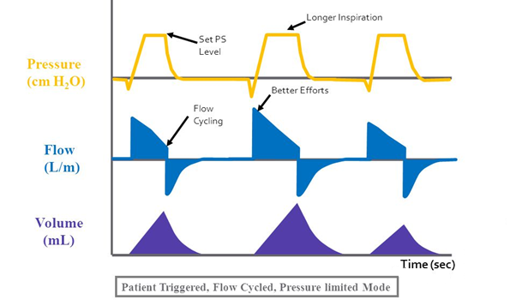

* In this mode of operation, the clinician sets the following parameters:

|  |  |
| --- | --- |
| * Support Pressure | * Sensitivity |
| * Pressure Rise Ramp | * PEEP |
| * Flow Cycle Off | * FIO2 |
| * Apnea Criteria |  |

* CPAP Continuous Positive Airway Pressure: Continuous positive airway pressure (CPAP) is a type of positive airway pressure, where the air flow is introduced into the airways to maintain a continuous pressure to constantly stent the airways open, in people who are breathing spontaneously. Positive end-expiratory pressure (PEEP) is the pressure in the alveoli above atmospheric pressure at the end of expiration. CPAP is a way of delivering PEEP but also maintains the set pressure throughout the respiratory cycle, during both inspiration and expiration. The application of CPAP maintains PEEP, can decrease atelectasis, increases the surface area of the alveolus, improves V/Q matching, and hence, improves oxygenation. It can also indirectly aid in ventilation, although CPAP alone is often inadequate for supporting ventilation, which requires additional pressure support during inspiration (IPAP on BiPAP) for non-invasive ventilation. Airway collapse can occur from various causes, and CPAP is used to maintain airway patency in many of these instances. The patient breathes naturally but at an elevated pressure (PEEP). In this mode of operation, the clinician sets the following parameters:
  + Positive End Expiratory Pressure (PEEP).
  + Sensitivity.
  + FIO2.
  + Pressure Rise.

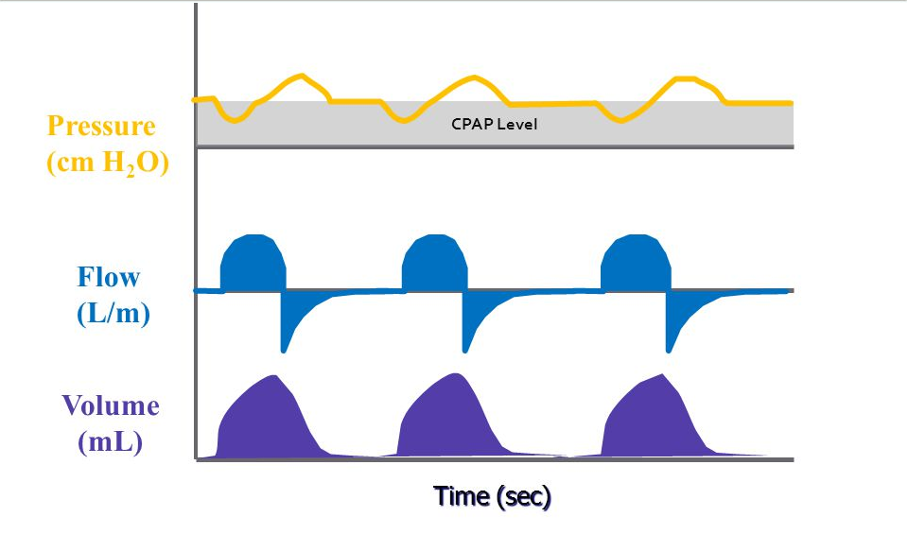

Airway collapse is typically seen in adults and children who have breathing problems such as obstructive sleep apnea (OSA), which is a cessation or pause in breathing while asleep. OSA may arise from a variety of causes such as obesity, hypotonia, adenotonsillar hypertrophy, among others. In this case, a continuous PEEP allows for high oxygenation by recruiting a high amount of alveolar tissues in mild ARDS. This mode of ventilation is a patient controlled mode of ventilation

* SIMV (VCV) PSV: Synchronized intermittent mandatory ventilation (SIMV) is a type of volume control mode of ventilation. With this mode, the ventilator will deliver a mandatory (set) number of breaths with a set volume while at the same time allowing spontaneous breaths. Spontaneous breaths are delivered when the airway pressure drops below the end-expiratory pressure (trigger). The ventilator attempts to synchronize the delivery of mandatory breaths with the spontaneous efforts of the patient. In contrast, to assist control ventilation (ACV), SIMV will deliver spontaneous volumes that are 100% driven by patient effort. Pressure support (PS) may be added to enhance the volumes of spontaneous breaths. Synchronized intermittent mandatory ventilation is typically used to help wean patients from the ventilator.  From a physiologic standpoint, SIMV has the advantage of avoiding acute respiratory alkalosis by allowing patients to achieve normal alveolar ventilation through an intact ventilatory drive. In this mode of operation, the clinician sets the following parameters:
  + PEEP
  + Tidal Volume
  + FIO2
  + Flow.
  + Pressure Rise Ramp.
  + Pressure Support
  + Flow Cycle Off
  + Sensitivity

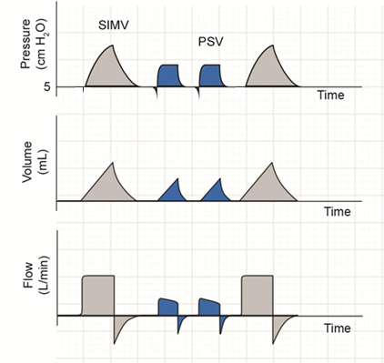

Often pressure support is utilized in order to allow for least work of breathing for a patient hence energy is greatly conserved. In VCV mode, AC-VC is utilized for mandatory breathing.

* SIMV (PCV) PSV: Synchronized intermittent mandatory ventilation (SIMV) is a type of pressure control mode of ventilation. With this mode, the ventilator will deliver a mandatory (set) amount of airway pressure to the patient for a set value of time. Spontaneous breaths are delivered when the airway pressure drops below the end-expiratory pressure (trigger). The ventilator attempts to synchronize the delivery of mandatory breaths with the spontaneous efforts of the patient. In contrast, to assist control ventilation (ACV), SIMV will deliver spontaneous volumes that are 100% driven by patient effort. Pressure support (PS) may be added to enhance the volumes of spontaneous breaths. Synchronized intermittent mandatory ventilation is typically used to help wean patients from the ventilator.  From a physiologic standpoint, SIMV has the advantage of avoiding acute respiratory alkalosis by allowing patients to achieve normal alveolar ventilation through an intact ventilatory drive. In this mode of operation, the clinician sets the following parameters:
  + PEEP
  + PIP
  + Ti
  + FIO2
  + Pressure Support
  + Pressure Rise Ramp.
  + Flow Cycle Off
  + Sensitivity

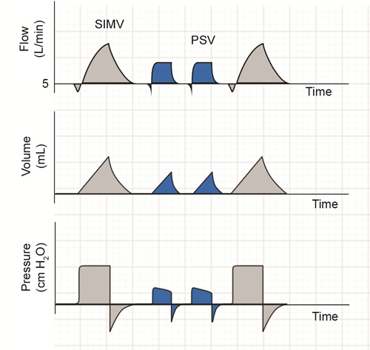

Often pressure support is utilized in order to allow for least work of breathing for a patient hence energy is greatly conserved. In PSV, a set pressure acts as a lung protection strategy.

* MMV (PSV): Mandatory Minute Ventilation coupled with pressure support ventilation is a combination of assisted controlled pressure control with pressure support ventilation used with a predetermined respiratory rate. The device in this case is programmed to monitor the number of breaths taken by the patient and compare it with the set RRMandatory by the clinician. In this mode, the patient is guaranteed a predetermined (expired) minute volume (VE), called the preset minute volume. If the patient is able to spontaneously breathe sufficiently to fit the preset minute volume, the ventilator does not deliver any mechanical breath. If the patient is unable to breathe spontaneously, the ventilator delivers mechanical breaths so that the patient receives a minute volume equal to the preset VE. If the spontaneous breathing of the patient is inferior to the preset VE, the remainder is automatically provided by the ventilator. The values of the preset VE and of the mechanical tidal volume (VT) are predetermined. The adjustments of the mechanical ventilation according to the changes in spontaneous breathing are usually (CPU 1) achieved by a modification of the rate of mechanical breaths. If the spontaneous ventilation exceeds the preset VE, the ventilator progressively decreases the frequency of mechanical breaths and can possibly stop delivering mechanical ventilation. Conversely, if the spontaneous ventilation is less than the preset VE, the ventilator progressively increases the rate of mechanical breaths.

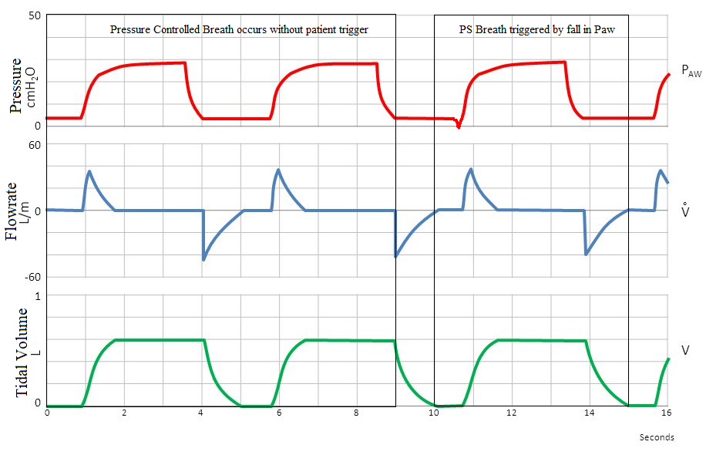

* In this mode of operation, the clinician sets the following parameters:
  + PEEP
  + Tidal Volume
  + FIO2
  + Flow.
  + Pressure Rise Ramp.
  + Pressure Support
  + Flow Cycle Off

# **DESIGN DRAFT OF THE LOW COST VENTILATOR**

Before considering a design for the low cost ventilator it is essential that the design of a professionally made one be understood. The following is a schematic of a basic ventilation system:

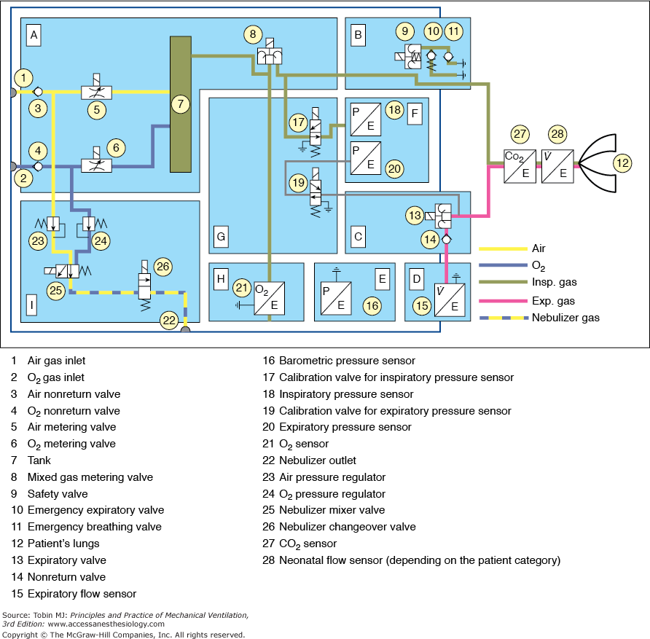

The above is the schematic of Pneumatic schematic of the Dräger Infinity V500 intensive care ventilator.

**A.** Gas-mixture and gas-metering assembly. Gas from the supply lines enters the ventilator via the gas-inlet connections for [oxygen](https://accessmedicine.mhmedical.com/drugs.aspx?GbosID=131723) and air (*1,2*). Two non-return valves (*3,4*) prevent one gas from returning to the supply line of the other gas. Mixing takes place in the tank (*7*) and is controlled by two valves (*5,6*). Inspiratory flow is controlled by a third valve (*8*).

**B.** Inspiratory unit consists of safety valve (*9*) and two non-return valves (*10,11*). In normal operation, the safety valve is closed so that inspiratory flow is supplied to the patient’s lungs (*12*). During standby, the safety valve is open and enables spontaneous inspiration by the emergency breathing valve (*11*). The emergency expiratory valve (*10*) provides a second channel for expiration when the expiratory valve (*13*) is blocked.

**C.** Expiratory unit consists of the expiratory valve (*13*) and a non-return valve (*14*). The expiratory valve is a proportional valve and is used to adjust the pressure in the patient circuit. In conjunction with the spring-loaded valve of the emergency air outlet (*10*), the non-return valve (*14*) prevents pendulum breathing during spontaneous breathing.

**D.** Expiratory flow sensor.

**E.** Barometric pressure sensor. Conversion of mass flow to volume, body temperature and pressure saturated (BTPS) requires knowledge of ambient pressure.

**F.** Pressure measurement assembly. Pressure in the patient circuit is measured with two independent pressure sensors (*18,20*).

**G.** Calibration assembly. The pressure sensors are regularly zero calibrated by connection to ambient pressure via the two calibration valves (*17,19*).

**H.** [Oxygen](https://accessmedicine.mhmedical.com/drugs.aspx?GbosID=131723) sensor.

**I.** Medication nebulizer assembly.

As discussed above, the design draft shall incorporate all the basic features of a basic ventilation device. Several basic designs have been proposed online, this design shall revolve around the design proposed by Makerere University.The device shall be divided into the following sections:

* Gas Metering and Mixing: In this section of the device, the gas shall be metered into the system via feed from (i). Clinical Air cylinder and (ii). Medical Oxygen to meet the FIO2 requirement setup by the clinician on the device. This assembly shall also feature the gas blender and accumulator to homogenize the mixture and store atleast 5L of dry/cold inspiration air mixture (~10 times average Tidal Volume capacity). At this point, though the gas temperature may be measure, but the heating and humidification operations shall be carried out in the humidifier assembly. This is so since heating the gas with no moisture content significantly reduces its overall heat capacity and hence would not allow for precise control over the temperature of the control gas.

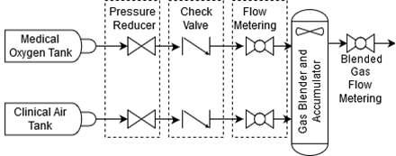

The schematic of the gas metering and mixing assembly are as shown above. The Oxygen and the air tank shall connect directly to the device. The device would then reduce the amount of the incoming gases. This is done in order to attain precise control over the flowrate of the gas and consequently the concentration of the mixture gas. To isolate the metering system pressure from the feed tank pressure, a check valve is installed after the pressure reducer valve. The incoming gas is then sent to the flow metering assembly where known volume of the gas flows into the gas blender and accumulator tank where the gas may be metered to the patient through the circuit.

* Patient Monitoring system: In this section of the unit, the patient pressure shall be monitored. This section shall be used to collect data and take appropriate actions based on the ventilation mode selected. Inhalation pressure and exhalation pressure shall be recorded along with the patient circuit temperature (as a measure of last check for inlet air temperature). These pressure sensors shall be connected to the blended gas flow metering section (INHALATION PRESSURE) while the ventilator exhaust shall be used for exhalation pressure. Along with measuring the Inhalation Pressure and Exhalation pressure other variables such as gas concentrations (such as in gas accumulator and the exit gas concentration), expiratory gas flowrate and PEEP shall also be monitored. These sensors can optionally be calibrated by using in-house calibration valves.
* Pressure monitoring system: The pressure monitoring system shall be responsible for monitoring the inlet pressure of gases (both air and oxygen). In basic ventilators, barometric pressure is also measured, but this feature shall be omitted in such a basic stage of the design.
* Expiratory filtration system: The exhaust of the filter shall be filtered before venting out of the system in order to avoid contamination through pathogens. This reduces the risk of infection to the medical staff.
* Emergency Inspiration/Expiratory Valve: This valve enables for spontaneous breathing in case of malfunction like exhaust or inlet choking. This allows for breathing through a resuscitation bag.

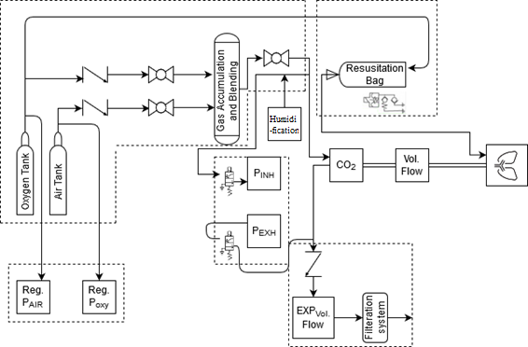

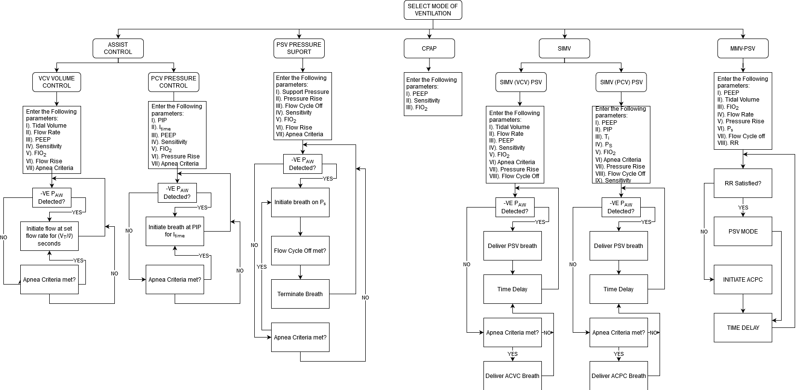

# **REFERENCES**

* Chatburn RL, Mireles-Cabodevila E: Basic Principles of Ventilator Design. In: Tobin MJ. eds. Principles and Practice of Mechanical Ventilation, 3eNew York, NY: McGraw-Hill; 2013. http://accessmedicine.mhmedical.com/content.aspx?bookid=520&sectionid=41692239. Accessed April 13, 2020
* Chatburn RL, Mireles-Cabodevila E: Assist Control In: Tobin MJ. eds. Principles and Practice of Mechanical Ventilation, 3eNew York, NY: McGraw-Hill; 2013. http://accessmedicine.mhmedical.com/content.aspx?bookid=520&sectionid=41692239. Accessed April 13, 2020
* Chatburn RL, Mireles-Cabodevila E: Synchronised internment mandatory ventilation modes . In: Tobin MJ. eds. Principles and Practice of Mechanical Ventilation, 3eNew York, NY: McGraw-Hill; 2013. http://accessmedicine.mhmedical.com/content.aspx?bookid=520&sectionid=41692239. Accessed April 13, 2020
* Chatburn RL, Mireles-Cabodevila E: Basic Alveolar fucntion. In: Tobin MJ. eds. Principles and Practice of Mechanical Ventilation, 3eNew York, NY: McGraw-Hill; 2013. http://accessmedicine.mhmedical.com/content.aspx?bookid=520&sectionid=41692239. Accessed April 13, 2020